JAVA EE (Jkarta EE)
Is a set of specifications that extends java SE to provide tools for enterprise application, including web applications, REST APIs, etc.

Key Components of JAVA EE
- Servlets
- JSP (Java server pages)
- JSF (Java server faces)
- EJB (Enterprise java beans)
- JPA, JDBC (Java persistence API)
- JAAS (Java authentication authorization service)
- Spring
- JMS (Java messaging services)

Web Application
- Any application which runs on the web (www) is known as Web Application.
- It has components like servlets, JSP, etc. and other elements such as HTML, CSS, JavaScript. These components execute in the web server and generate response to any http requests.
Websites are of two types static and dynamic:
- Static: Such website that provide some set of information which cannot change.
- Dynamic: It dynamically changes the information of the objects using different technologies.

Http (hypertext transfer protocol)
It is the foundation of the communication on www, It is set of rules that govern how data is exchanged between web browsers and web servers.
Http is a stateless protocol.

Client server model
Http follows client server model. Here web browser or the client initiates a request to a web server which tend sends a response. It allows transfer of various data types, texts, images, videos and audio, etc.
Each Http request and response is treated as a separate interaction, meaning they don’t retain any information about previous request from the same client.

Web Server
Web server is a software which handles http requests and responses. It serves static content like html, css, javascript and images etc.
Some examples are appache http server etc.
A pure Web Server cannot run java servlets or JSP’s. For that we need a web container.

Web Container
Web Container is part of an application server or a specialized server like a appache tomcat. It manages the life cycle of servlets and JSP’s enabling execution of dynamic web content.
Apache tombcat, jetty and glass fish

Servlets are the java programs that run on a server/container and handle client requests to generate dynamic web content. They are key component of java EE to developing web application.

Request and Response

REQUEST
It represents the clients request to the server. It contains information like http methods (get, post, etc.), Headers, Parameters, and the request body.

RESPONSE
It represents the server’s response to the client. It includes the status code, headers and the response body (HTML, plain text, json, etc.)

Servlet Life Cycle
A servlets life cycle is managed by the web container it involves four stages loading and instanton
PHASE 1: Loading and Instanton
Loading > When the web container is start when the request is received for the servlet the container loads the servlet class.
Instanton > If an instance of the servlet doesn’t exist, the container creates the single instance.
PHASE 2: Initialization
Initialization >
  - init() – this method is called only once after the servlet instance is created. It is used to initialize the servlet, setting up database connection, reading configuration files, etc.
PHASE 3: Request Handling
- Service () - This method is called for each request to the servlet its responsible for processing the client request (example: reading request parameters, accessing session data).
- Generating response- (creating html content, setting headers, writing the response to the output stream)
PHASE 4: Destruction
- Destroy () - This method is called only once before the servlet is unloaded. It is used for cleaning of resources like closing database connections, releasing threads, etc.
- It is used to perform any necessary cleanup task.

Http methods

get() : It is used to retrieve data from the server

post(): It is used to send data to the server.
Put(): It is used to update data on the server.
DELETE(): It is used to delete data from the server.

Servlets are of two types
- Generic servlet
- Http servlet
Generic Servlet: Provides a protocol independent way to handle request and generate responses it is often used for custom protocols or non-http based communication. It is less common in modern web development.
Http Servlet: It is specially designed to handle http requests and responses.
It provide methods like doGet(), doPost(), doPut(), doDelete(), to handle different http methods it is most commonly used for web application.
Print Writer: It serves as a powerful tool for generating dynamic content and sending it back to client browser
It provides simple and efficient way to write text base data to the http response stream.
It directly writes text data to the servlet response stream, bypassing the need for intermediate buffers or object serialization. This results faster and more efficient output.

14|1
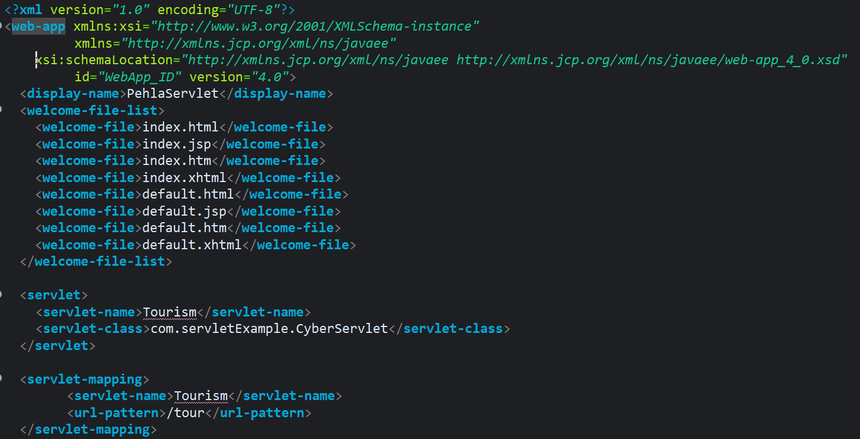
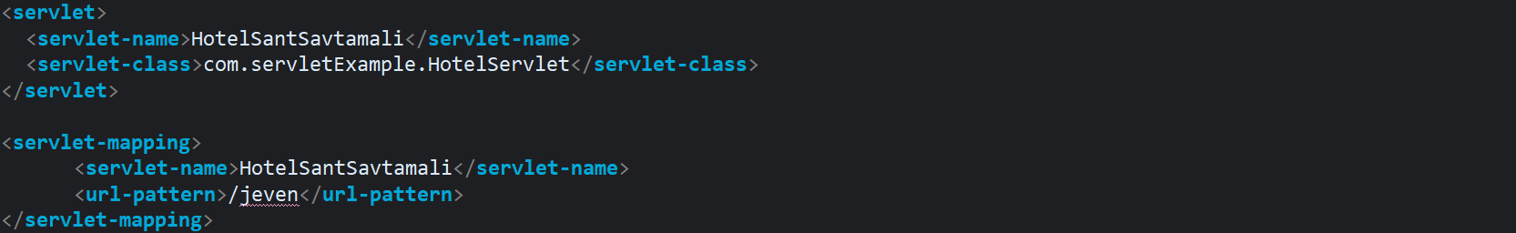
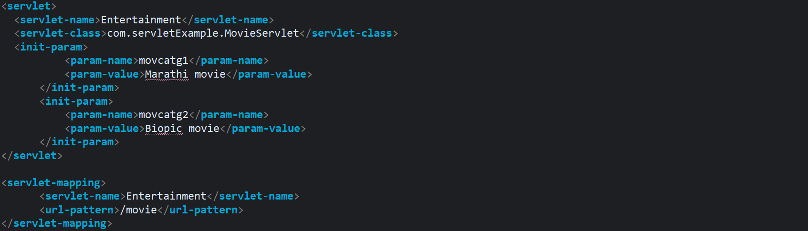

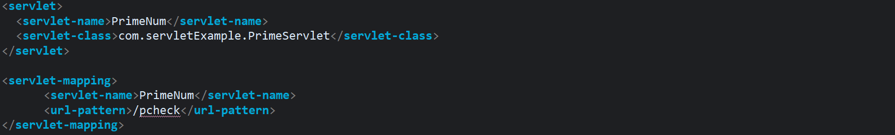
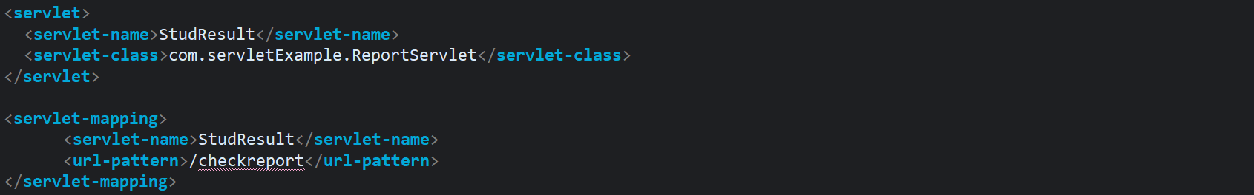

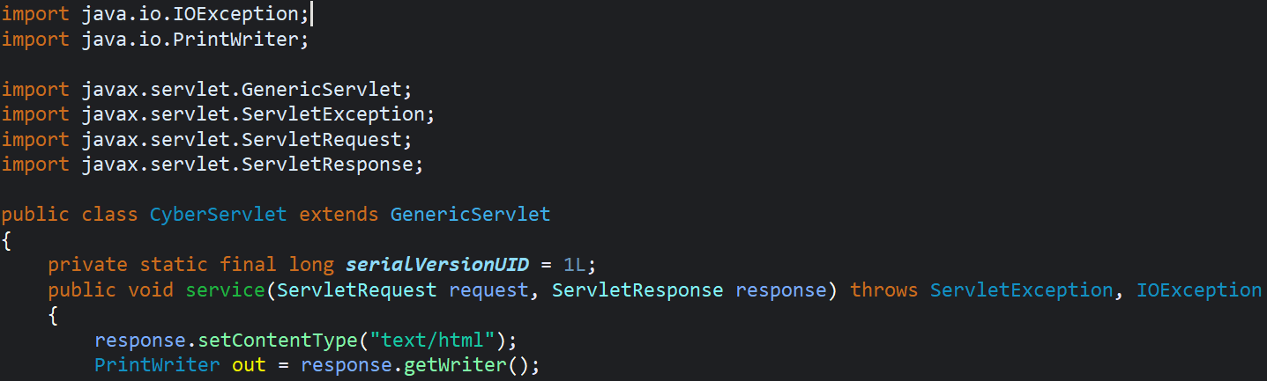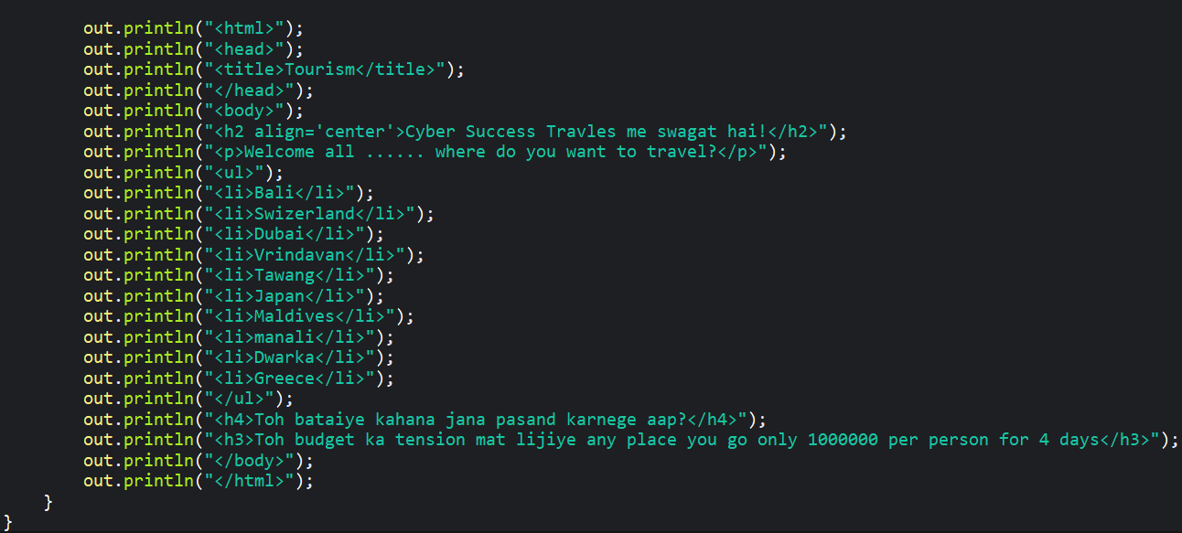

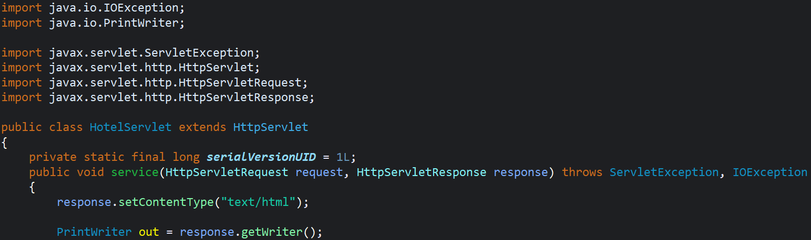
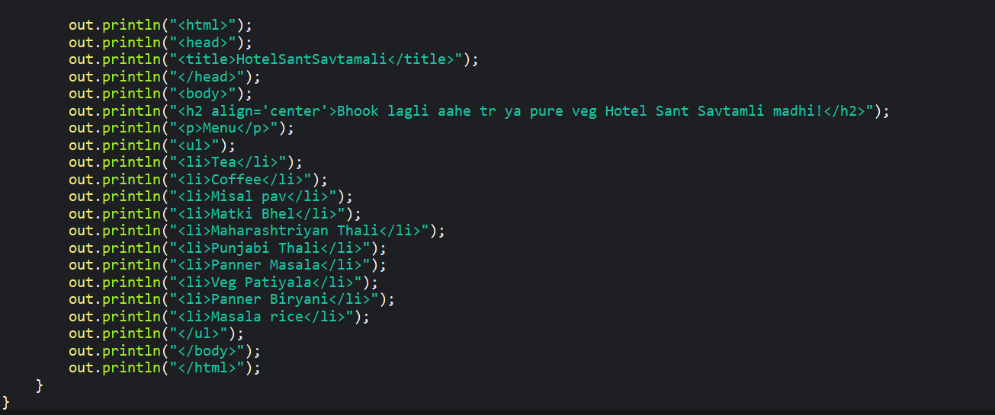

15|1
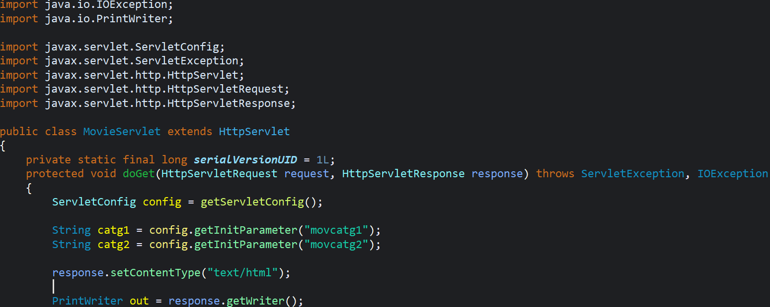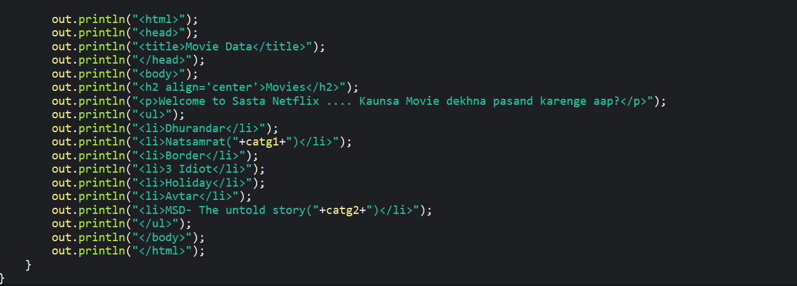
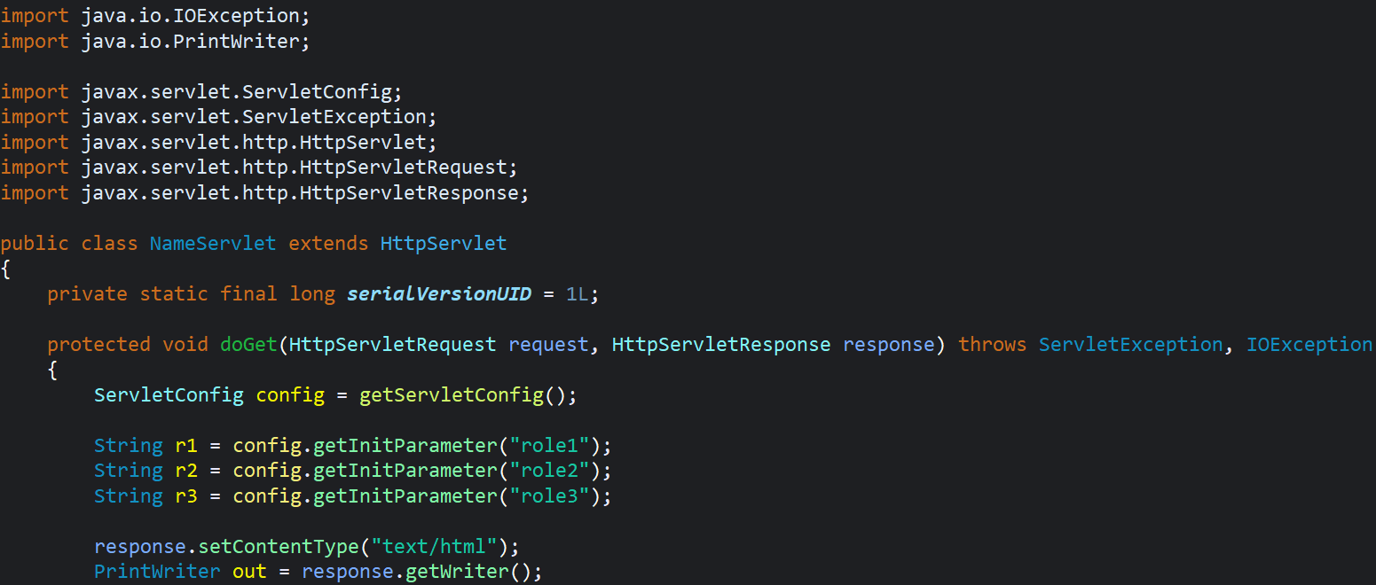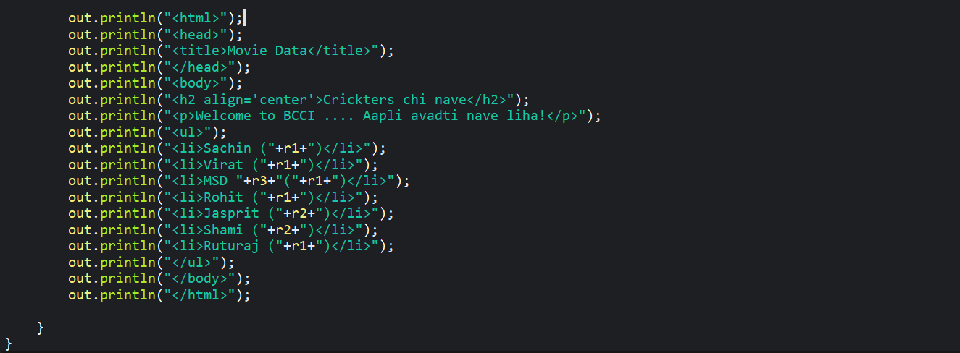
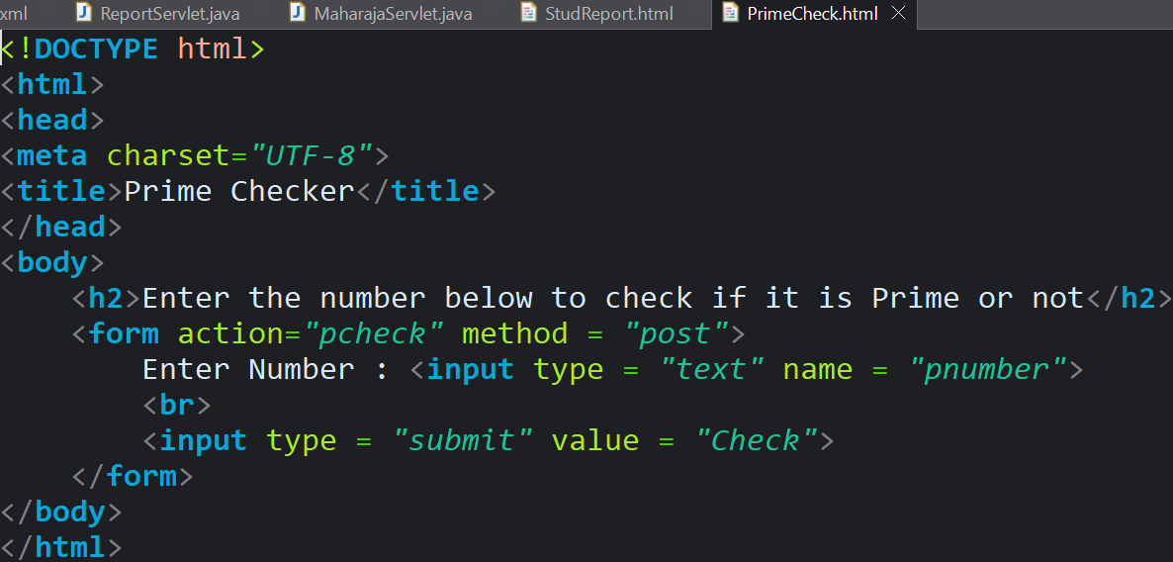
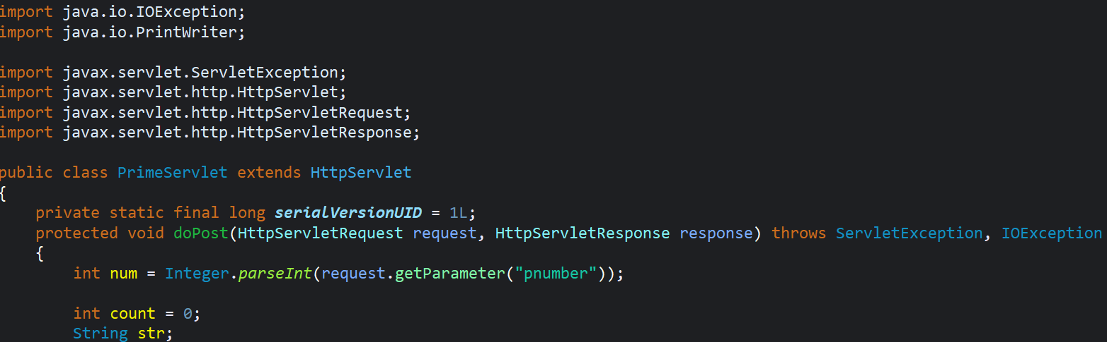
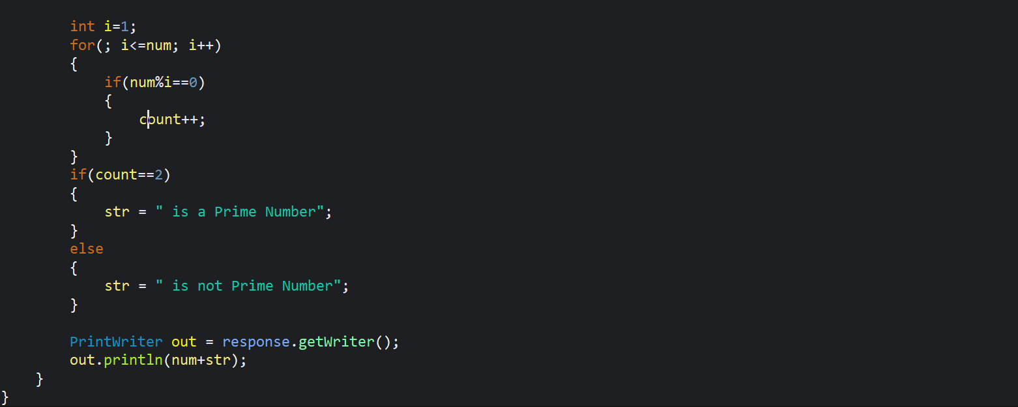
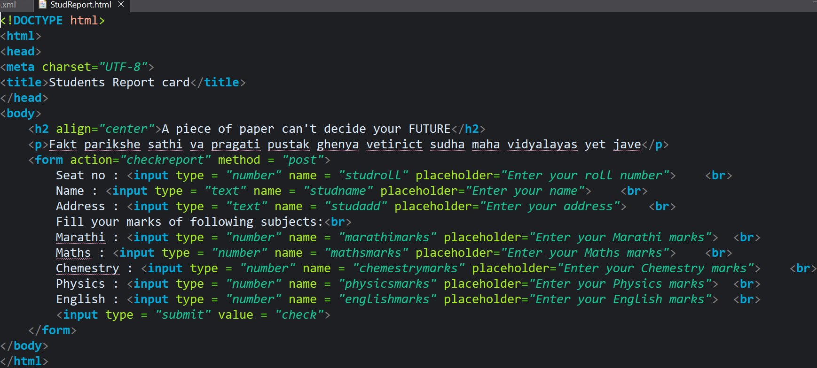
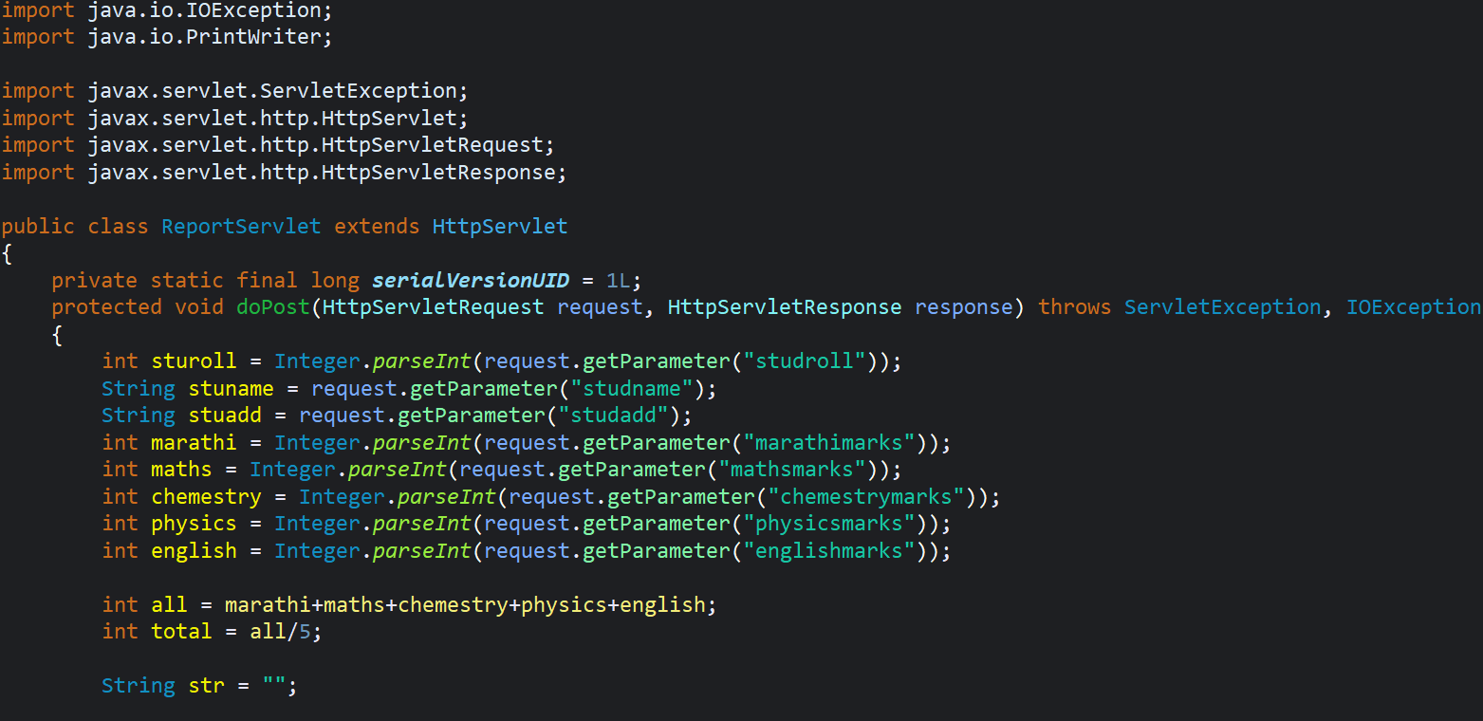
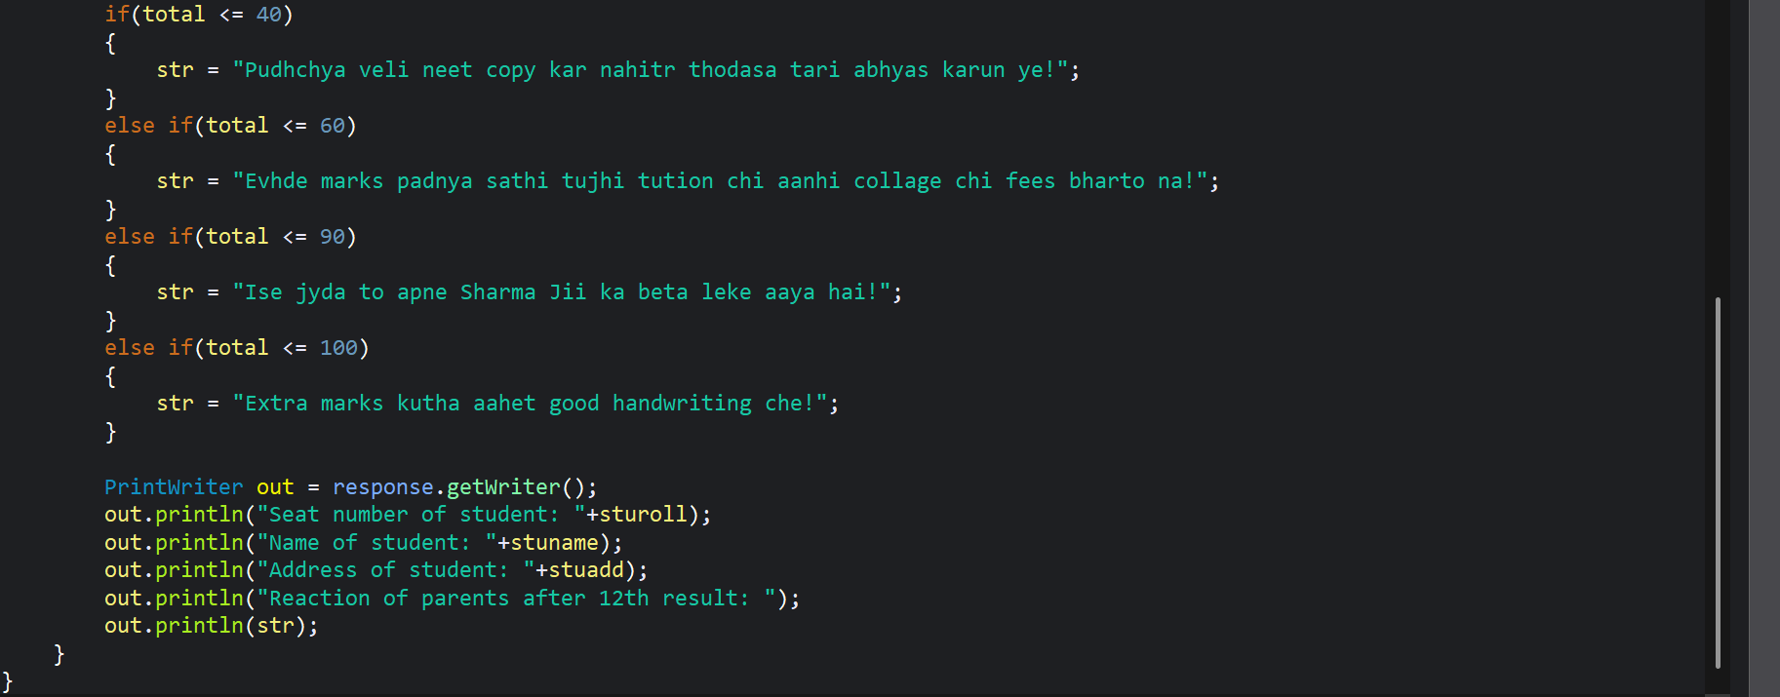

Servlet Config

It is the interface within the java servlet package and it serves as configuration provider for servlets, offering access to initializing parameters and other deploying information’s defined in the web application deployment descriptor (web.xml).
- <init-param> It is the element used within the deployment descriptor to define key-value pairs that provides configuration settings for servlets.
- The primary advantage of the servlet config in java servlet lies in the ability to separate configuration details from servlet code.

SCOPE
The servlet config object is specific to its particular servlet instance and each servlet gets its own servlet config during initialization.
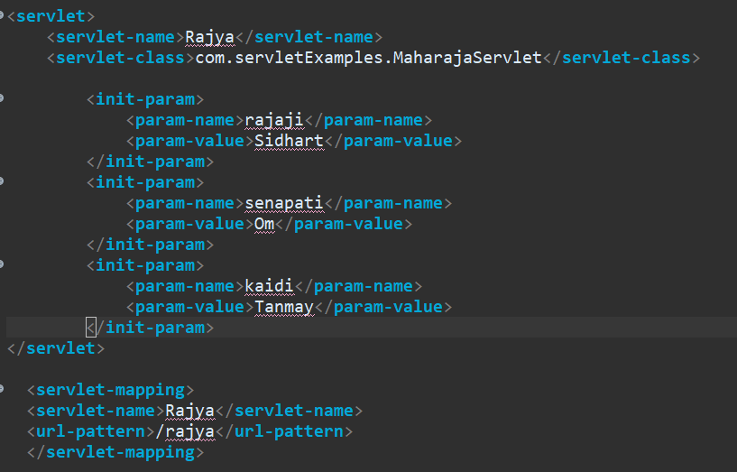
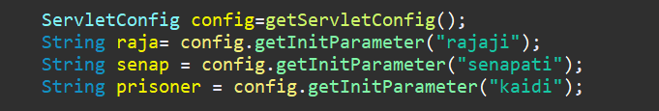

Servlet Context
It is an interface in the javax.servlet package and represents the application-level context for the web application meaning one servlet context object is created per application and is shared by all servlets, filters and jsp in that application.

Context-param
It is used within the deployment descriptive file (web.xml) of java application, it serves the purpose of defining initialization parameters that holds application by configuration settings
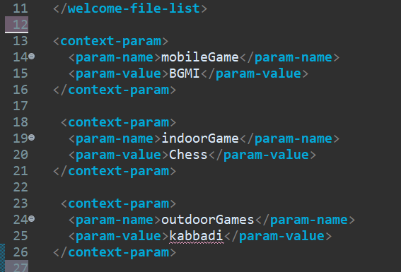

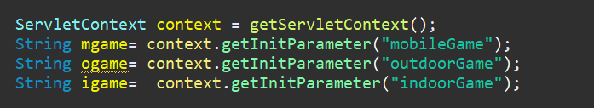

Inter Servlet Communication
In web development inter servlet communication refers to the technique used by servlet to share information with each other. Servlets are program that run on web servers and handle requests from web browsers. Since a single servlet might not have all the information needed to process a request, servlets often meet to communicate with each other to full fill user requests. Some common ways by which servlets can communicate with each other are
- Request dispatcher
- Context parameter
- Request attributes
- Session management

Request Dispatcher
RequestDispatcher (Interface) allows a servlet to forward a request to another resource (another servlet file, jsp file or html file) or to include the content of another resource in the response.
Methods provided by RequestDispatcher:-
- Forward (request, response) > It forwards the request from one servlet to another resource on the server.
- Include (request, response) > It includes the content of another resource in the response.

LoginPage.html
- 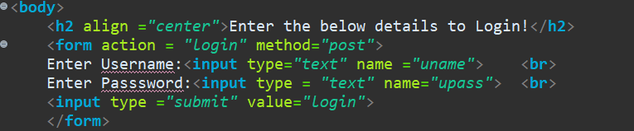
LoginServlet>>>doPost()
- 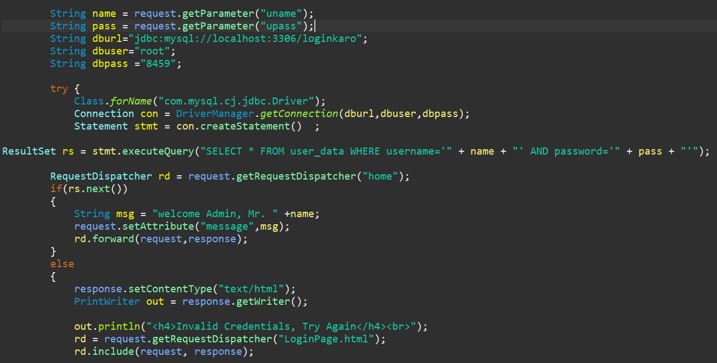
- 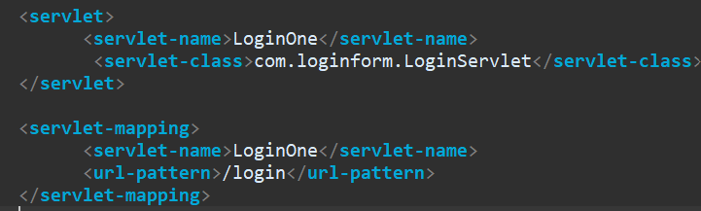
HomeServlet>>>doPost()
- 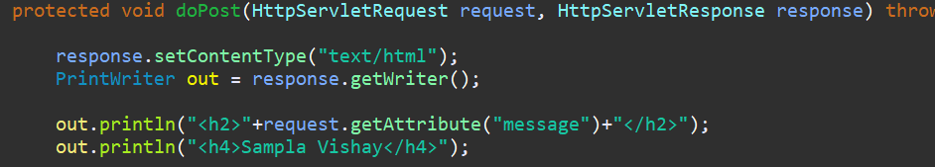
- 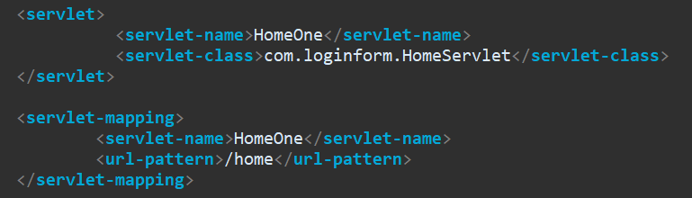

SendRedirect()
SendRedirect() is of servlet response interface that is used to redirect the client browser to a different url.
HomeServlet
LoginServlet
Login.html
/login /home

LoginForm.html
- 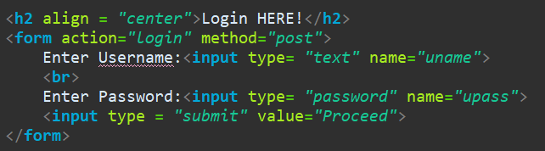
LogServlet.java
- 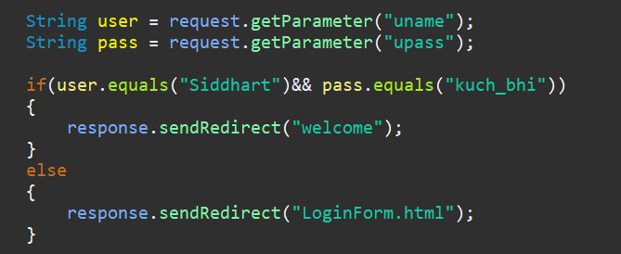

- Web.xml
- 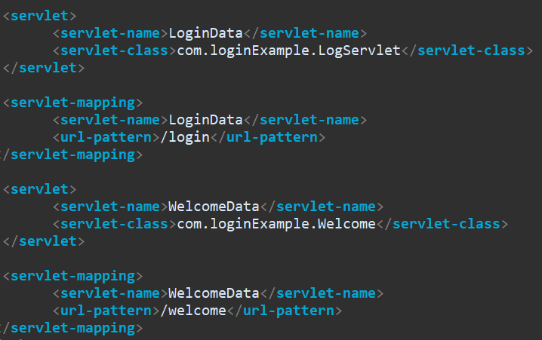
- Welcome.java
- 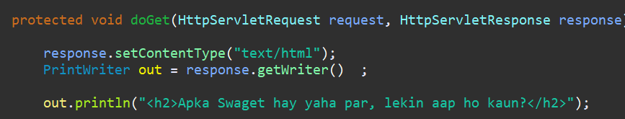

Filter
Home Server
Filter
Client

A servlet Filter in java is a class that acts as control value in communication pipeline between the client and servlet in a web application.
It essentially acts an interception layer for request and responses, allowing us to perform actions before they reach the servlets and after servlet finishes the processing filters can intercept and manipulate both the request and response object, this enables them to perform various tasks such as data validation, authentication and authorization, login, etc.

Session Management
A Session refers to a mechanism that allows a web application to maintain information about user across multiple requests this is important because Http protocol is stateless protocol without session the server will not recognize a user returning to our web application after they visited the page.
Http Session Interface
It is used to manage sessions; we can get the reference to current reference by using getSession().
Different techniques for session management are
- Session Object
- Cookies
- URL rewriting (not used now a days)
- Hidden Form Field (not used now a days)
Benefits of Session management
- Maintains user state it allows us to store user specific data like preferences, shopping cart, etc.
- Improved user experience, it enables features like remembering login details, giving track of items added to shopping cart, etc.

- LoginServlet
- 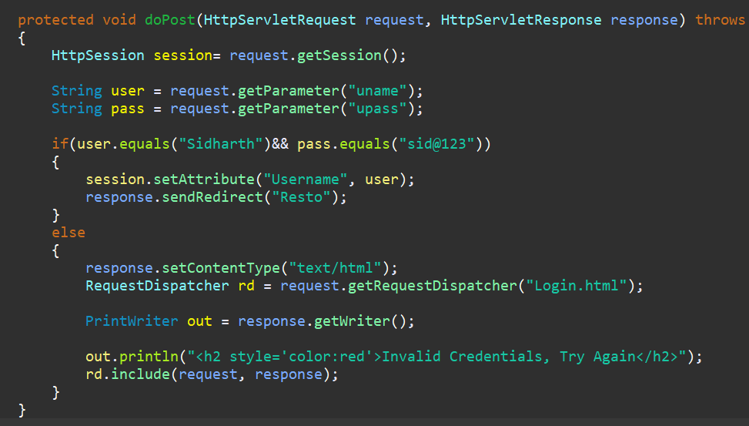
- ResturantServlet
- 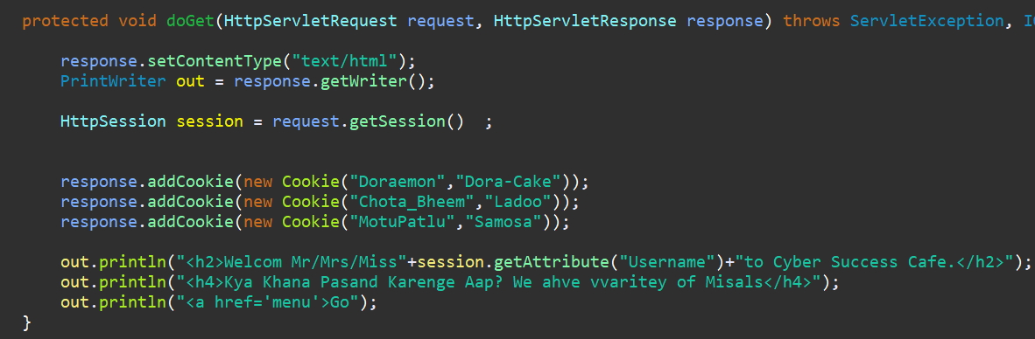

Cookies
Cookies are small text file that a web server sends to a user’s browser. These cookies are sent back to the server with each subsequent from the same browser.
Cookies are primarily used for tracking user sessions, maintaining login state, storing user preferences such as language, theme or font size.
If you are using session tracking the servlet container will create a session cookie (JSESSIONID) to keep track of the user’s session. The session cookie is generated when you call request.getSession(). For the first time in your servlet this JSESSIONID cookie is used to maintain a connection with the server across multiple requests.
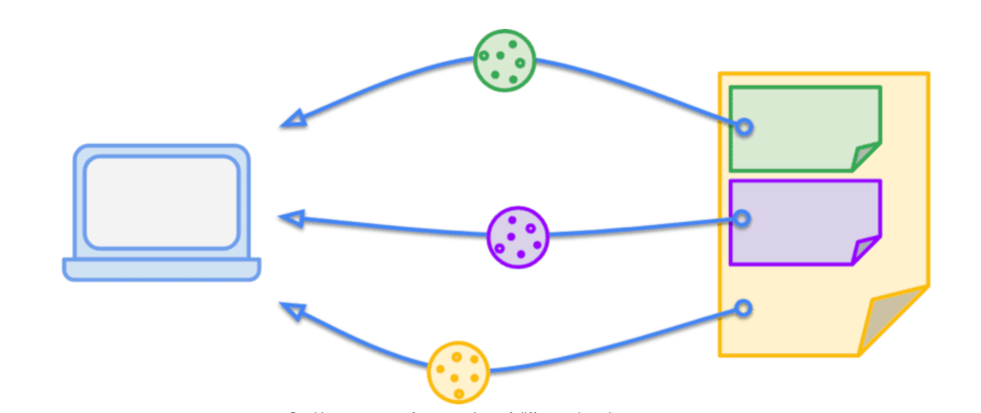

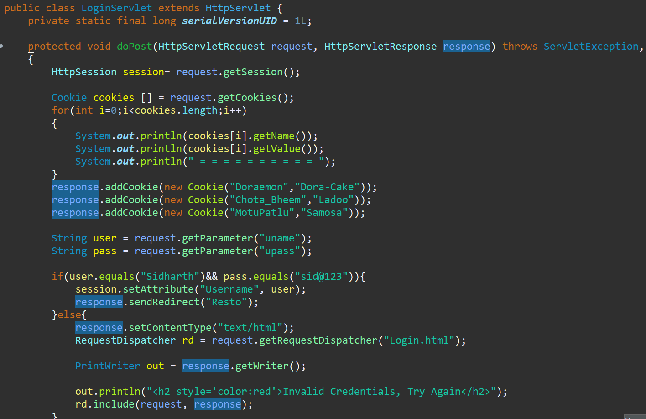
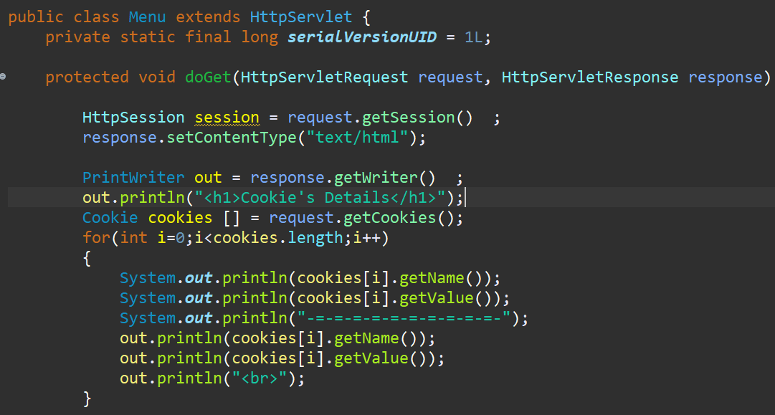
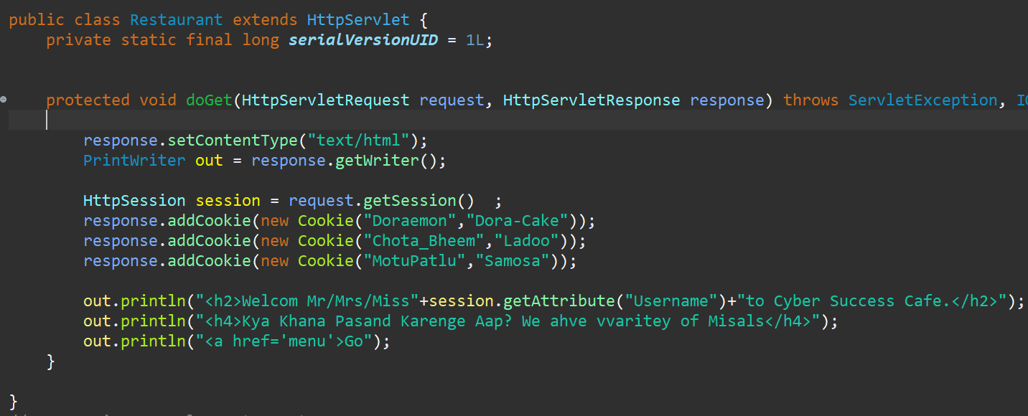
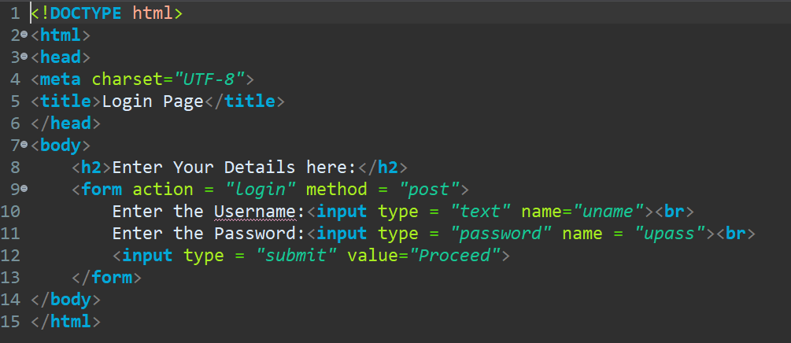
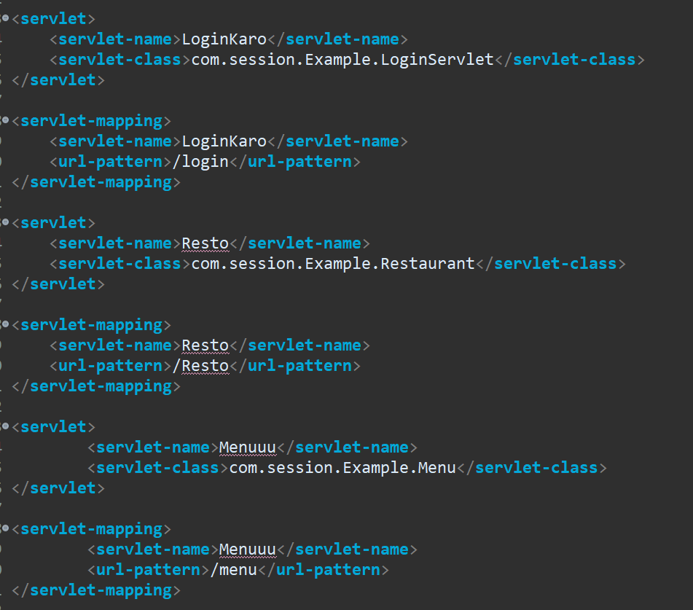
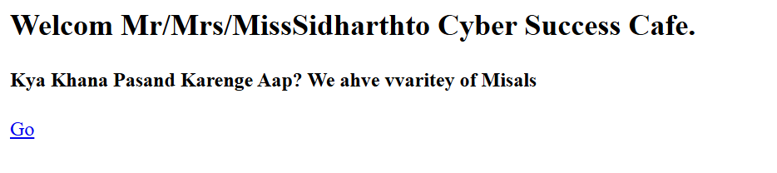
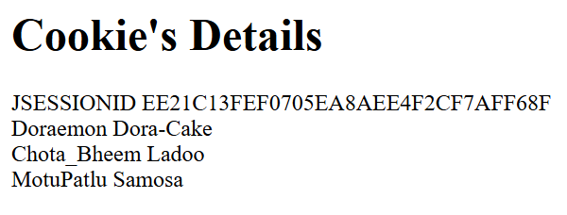

LOGIN LOGOUT EXAMPLE
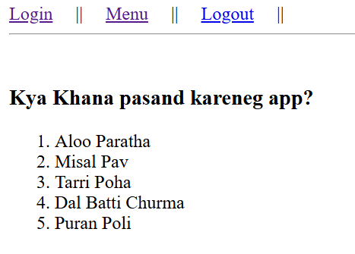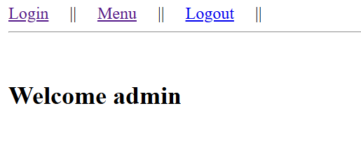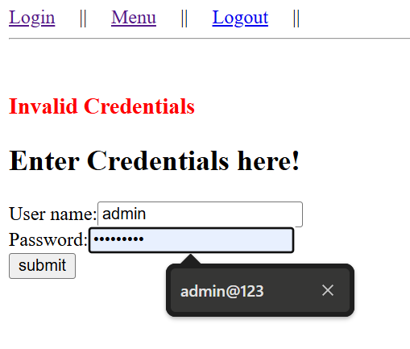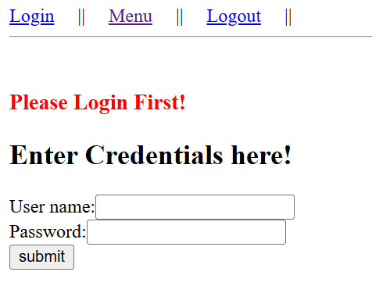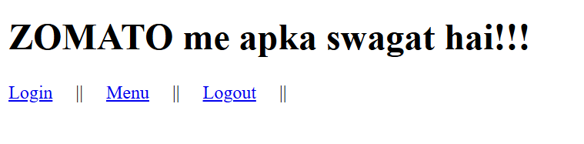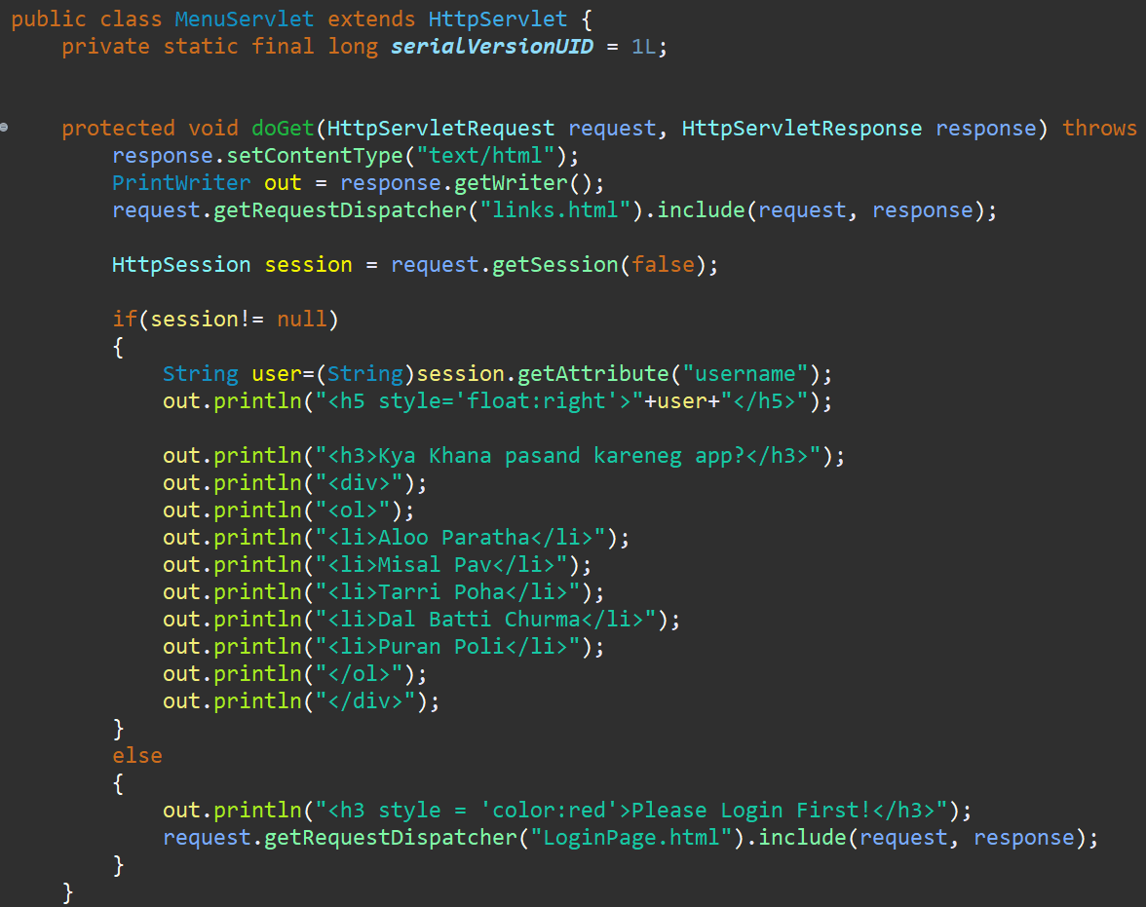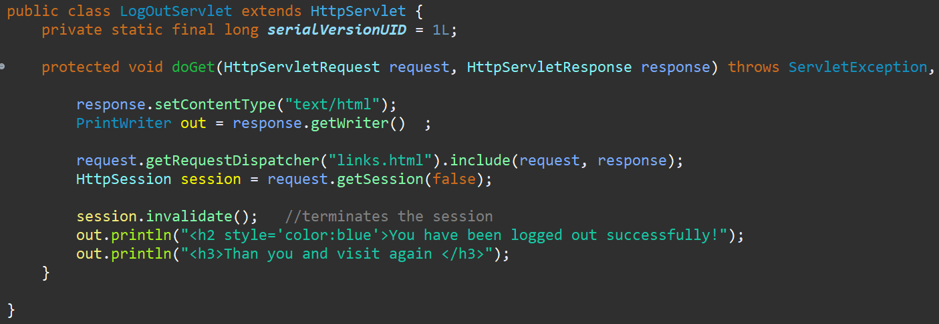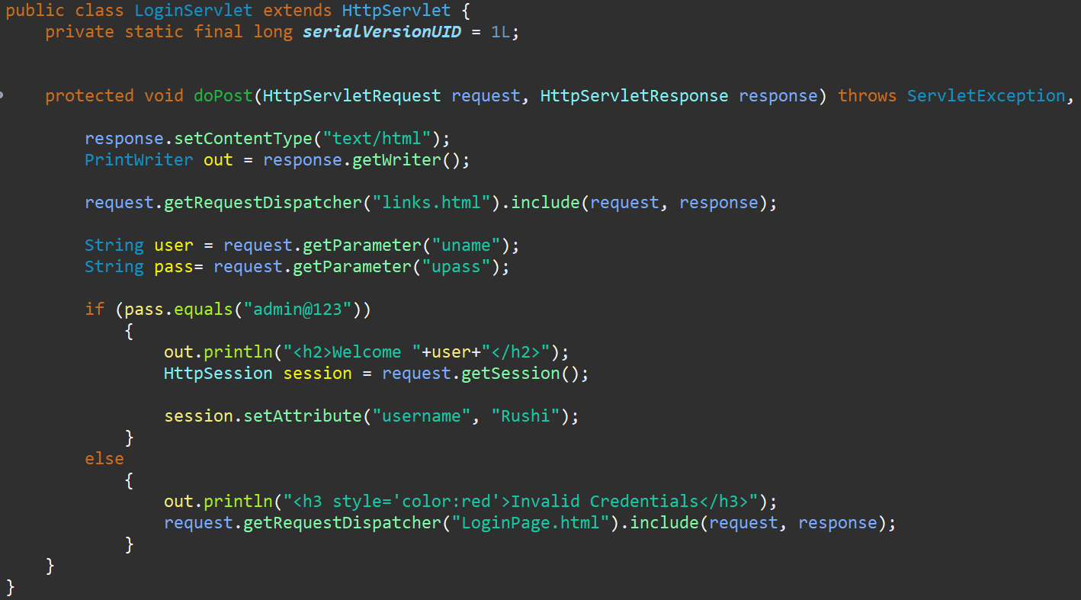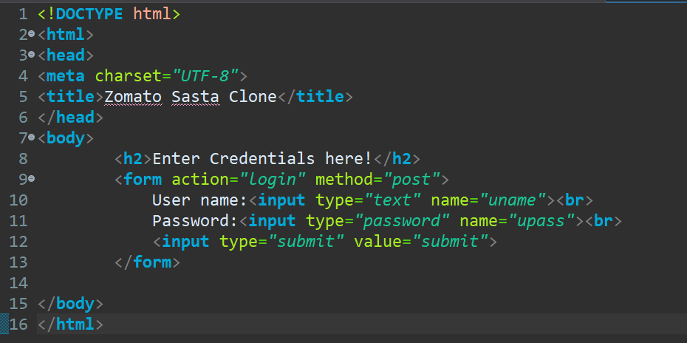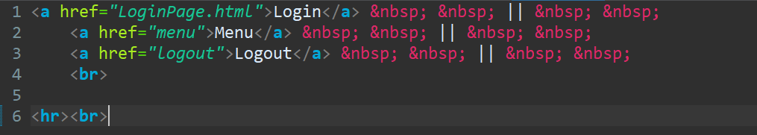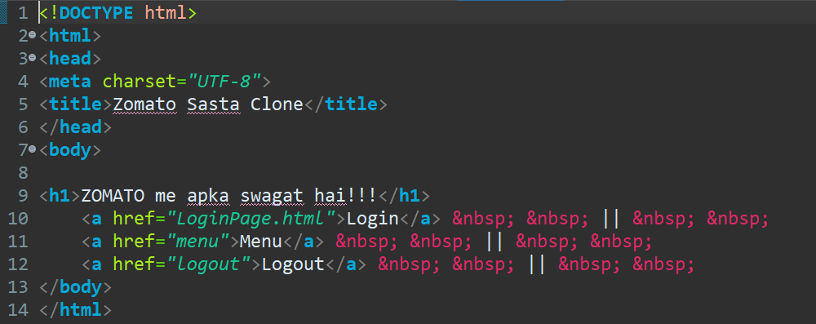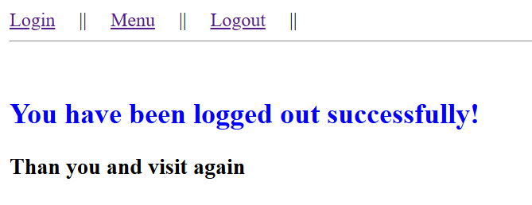

JSP (Java Server Pages)
JSP stands for java Server Pages. It is technology used to develop dynamic web applications. It allows developers to create interactive web pages that can respond to user input and generate content then and there.
JSP pages are combination of HTML and JSP tags. These disclosed within special parameter (% //java code%) and it can embed java code snipits directly into HTML
snipits= block of a code

JSP Life Cycle
- Translation
- Compilation
- Instantiation
- Initialization
- Service
- Destruction
Translation:
- When JSP page is first requested, the JSP container (part of the web server) takes central stage.
- It parses the JSP page identify and separating the HTML code from the JSP tags.
- These JSP tags are then translated into their equivalent java code snippet;;, resulting in complete servlet class containing the embedded java code.
Compilation:
- This page involves compiling the newly generated servlet class into bytecode, a machine-readable form.
Instantiation:
- If the bytecode is not available (for new JSP page or after server restarts) in that case, new instance of the generated class is created.
Initialization:
- jspInit() – Once an instance of servlet class exists the container invokes a special method with class called jspInit().
- This method is designed for initialization tasks specific to JSP page, such as opening database connection or setting up a resource.
- The jspInit() is typically called only once throughout the JSP life cycle.

Service:
- This is the heart of the JSP life cycle the actually processing of user request is placed.
- This method is responsible for handling user interactions, retrieving data and generating the dynamic content.
JSP Destroy:
- When the JSP page is no longer needed the container invokes the jspDestroy().
- This method allows the JSP to perform the any necessary clean up tasks such as closing database connectinons and releasing resources.
- The jspDestroy() is called only once during end of JSP life cycle.

Implicit Objects
Implicit Objects are predefined objects, which may be available by JSP container to every JSP page. These objects eliminate the need for explicit creation, initialization, making JSP simple for the development.
There are seven commonly used implicit objects in JSP such as Request, Response, out, etc.
- Request (HttpServletRequest): It represents the HttpServletRequest Http associated with current user request it can provide access to information like request parameter submitted through from using request.getParameter() etc.
- Response (HttpServletResponse): It represents the // used to send content back to the client browser. It is also useful for redirecting user to another page and setting cookies.
- Out (JSPWriter): It provides a way to write content to the response stream, displayed on the client’s browser.
- Session (HttpSession): It represents the users Http Session it enables the storing and retrieving the session specific data across multiple requests from the same user.
- Application (ServletContext): It represents the context of entire web application.
- Config (ServletConfig): It represents the configuration / information of the JSP page.
- Exception (Throwable): It provides access to exception object that causes the error.

SCRIPTING ELEMENTS
JSP scripting elements allows us to embed java code directly with the JSP page it is of three types
- Declarative Tags <%! %>: This tag is used to define variables or methods that have class wide scope within the generative servlet class. This element is placed outside of any HTML tags and are processed only during the translation phase.
- Expression Tags <%= %>: This tag is designed for single purpose like evaluating a java expression and printing the results directly into the output string. It is concise and official for displaying variable values, performing calculations etc.
- Scirptlets: <% %>: Scriplets are the most versatile type of scripting elements. We can use Scriplets for various tasks like accessing and modifying variables, performing calculations, interacting with objects for access, Session management, controlling the flow of logic using conditional and looping statements etc.
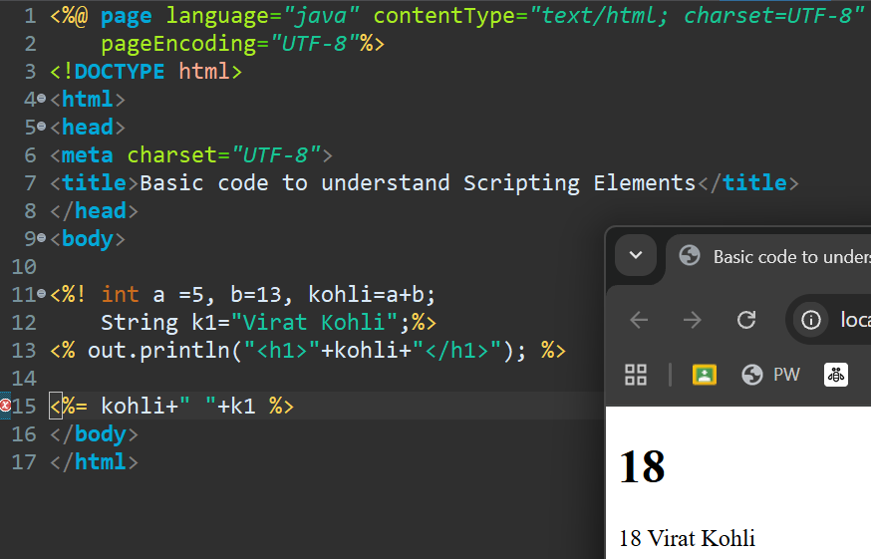

Directives <%@ %>
Directives are special elements that provides instructions to the web container on how to process and translate a JSP page into its corresponding servlet. These Directives are essentially messages that configure various aspects of the JSP page behavior.
There are three types of directives
- Page Directive %@page ”% :Page directive is used to define various attributes that applies to the entire JSP page some common attributes are import, content type, extends, page encoding, etc.
- Include Directive <%@include %>: It is used to include content of another file (HTML, JSP, Text Files) into the current JSP page. This is useful for creating reusable components like headers, footers or navigation menus.
- Taglib Directive <%@taglib %>: This Directive is used to declare custom tag libraries or standard tag libraries that we want to use within JSP page. Tag libraries provide reusable components and functionality that can simplify JSP development.

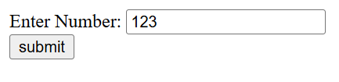
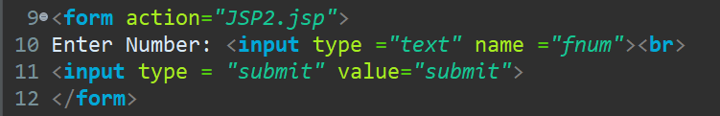

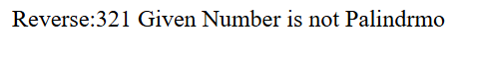
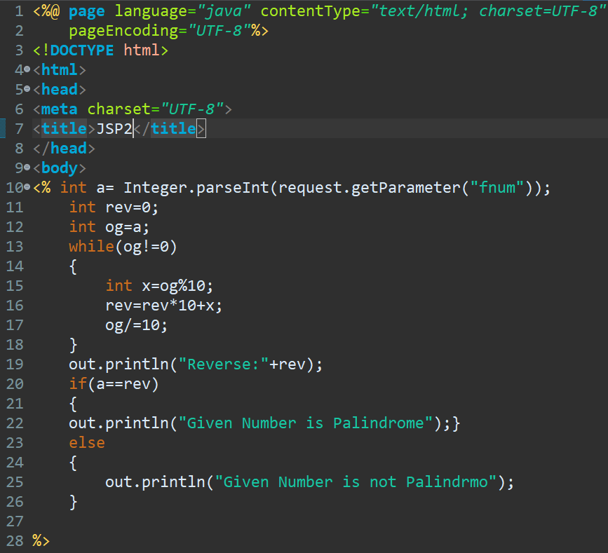

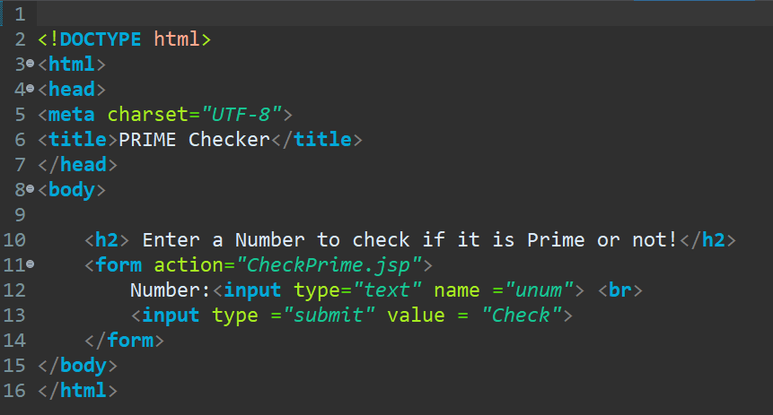
CheckPrime.jsp>>>

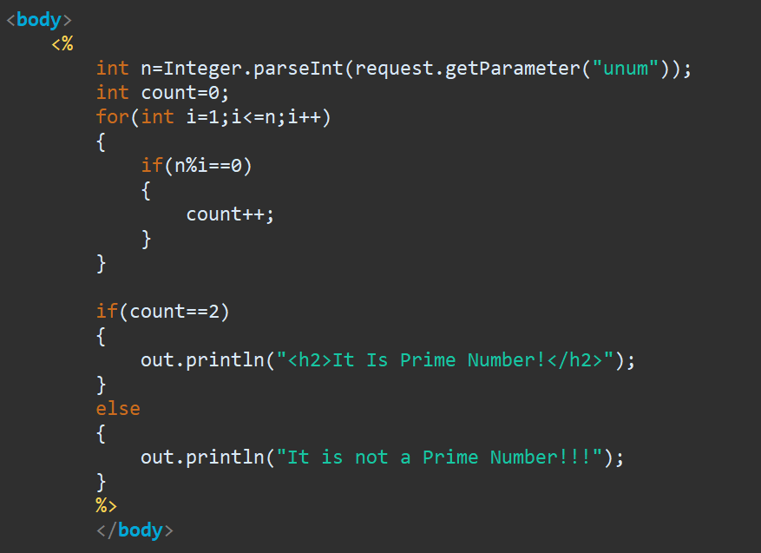

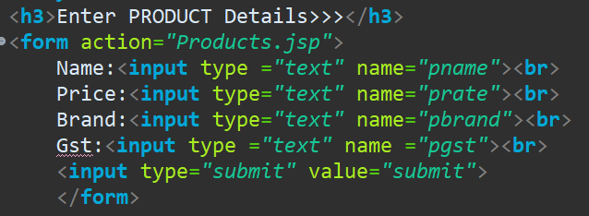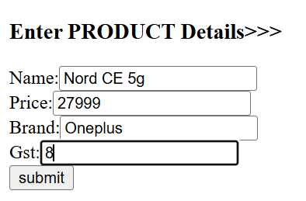

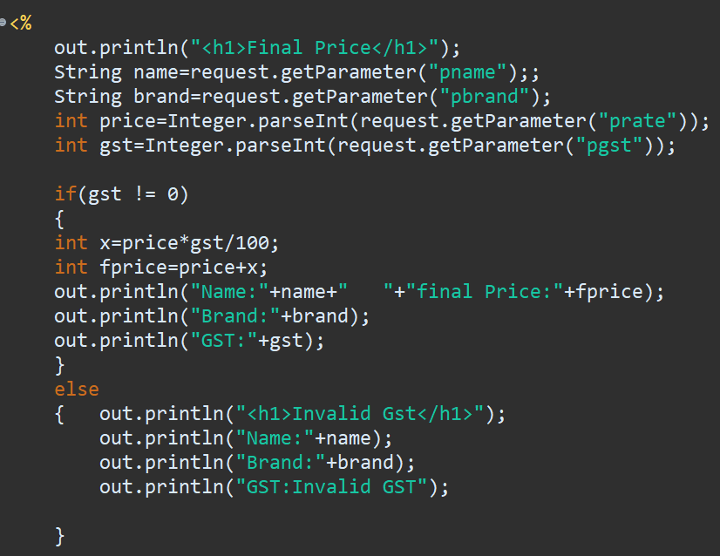
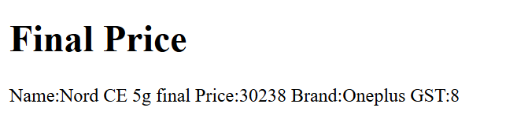
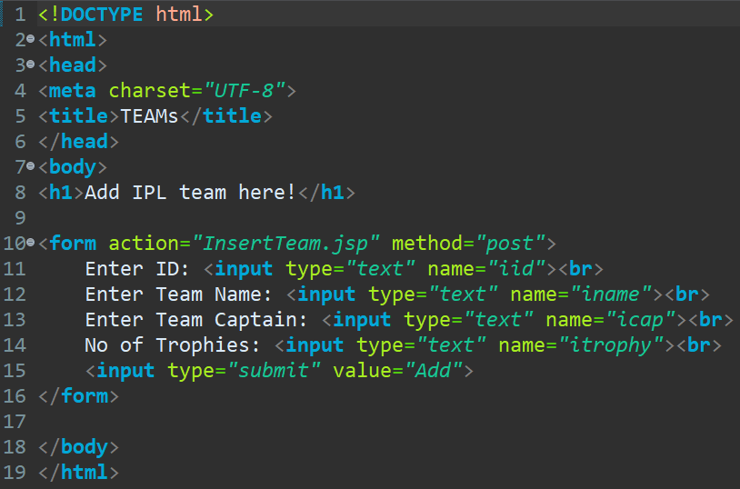
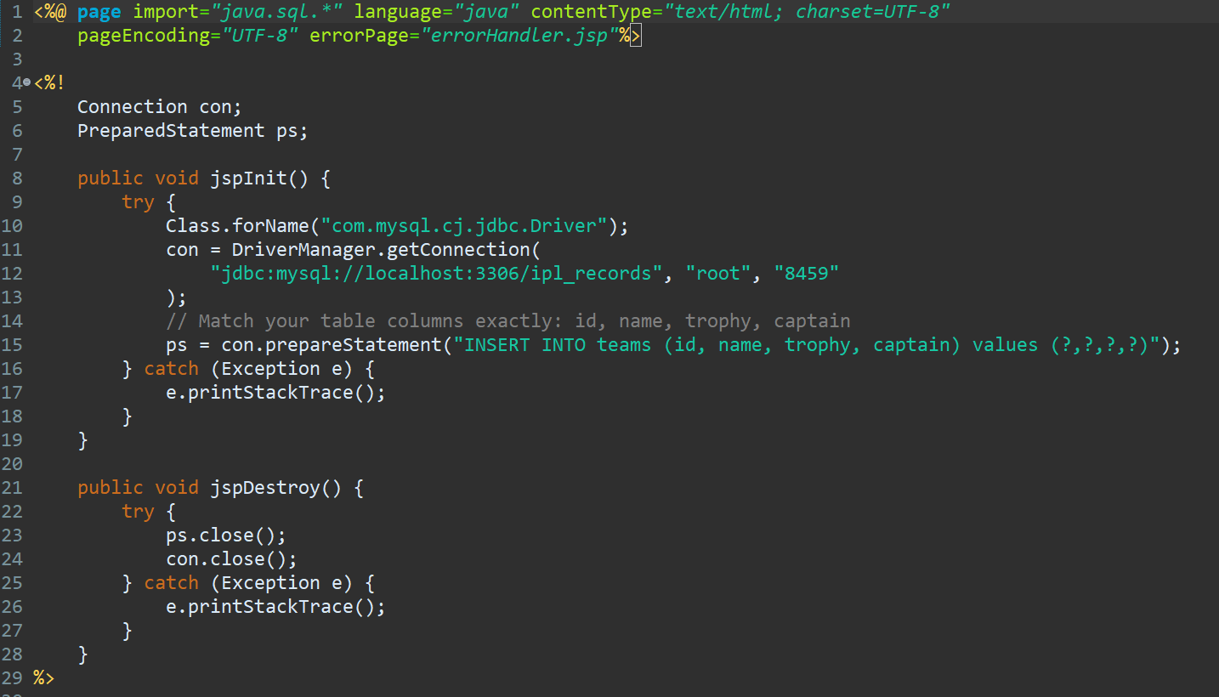
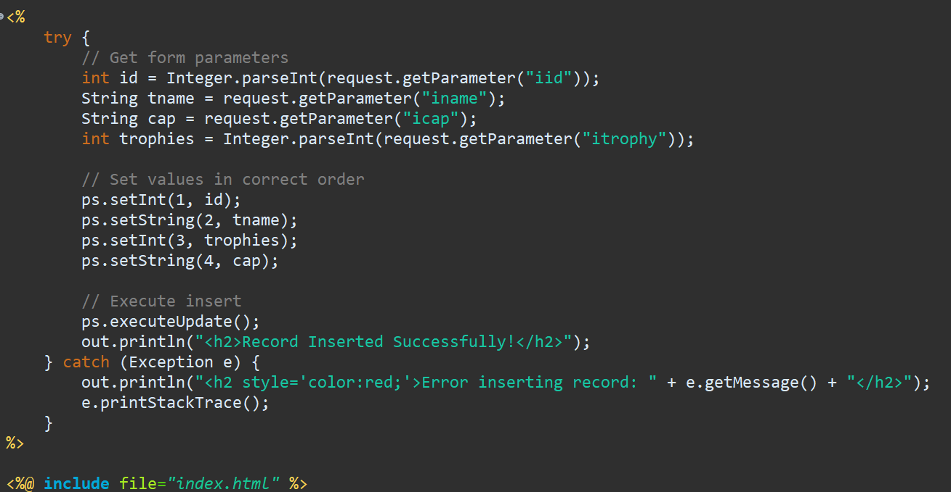

Action tag
Action tag is special element in JSP that provides dynamic functionality and control the flow of execution within a JSP page.
Common action tag and their functionality
- < JSP: include >: It includes the content of another JSP page at the point where the tag appears.
  - Page attribute: It specifies the URL of the JSP page to be include.
- < JSP: forward >: It redirects the request to another resource (JSP, Servlet, static content)
  - Page attribute: It specifies the URL of the resource to be forwarded to.
- < JSP: Param name =” “ value= “ “>: It is used in conjunction with JSP include and JSP forward tags to pass parameters to included or forwarded content called resources.
  - Name attribute: It is the name of the parameter.
  - Value Parameter: It is the value of the parameter.
Display.jsp
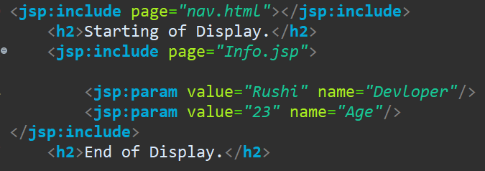
Info.jsp
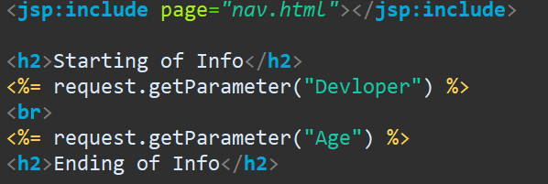
Nav.html
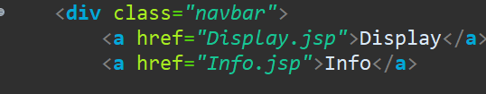

BEANS
<jsp:useBean>: It creates or retrieves a java bean object from the request, session or application scope.
- Id- It holds the name of java bean object.
- Class- it holds the fully qualified class name of the java bean.
<jsp:setProperty>: It is used to set properties of java bean object
- Name- It holds the name of the java bean object.
- Property- It holds the name of the property to be set.
- Value- It holds the value to be assigned to the property.
<jsp:getProperty>It is used to retrive value of property from a java bean object
- Name- It holds the name of the java bean object
- Property- It holds the name of the property retrieved from.

Product.java
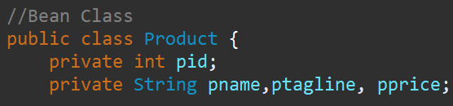
ProductData.jsp
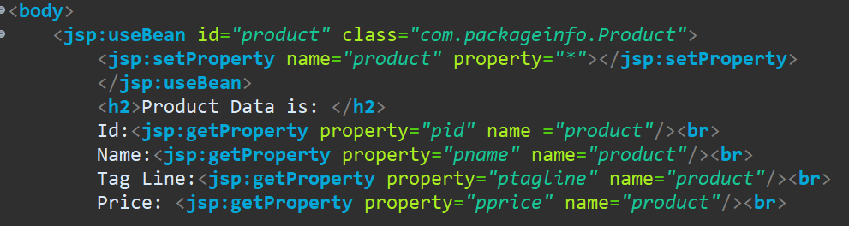
ProsuctForm.html
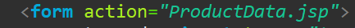

JSTL (Java Standard Tag Library)
JSTL is a collection of tags that simplifies coding in JSP. It provides more concise and readable way to perform common tasks like iterating through collection handling condition statement etc.
It provides a way to embedded logic within out JSP pages using a syntax similar to the HTML tags, include of writing lot of java codes within Scrip Leets JSP is mainly divided into five tag libraries
- Core tags
- Formatting tags
- SQL tags (Deprecated)
- XML tags (Deprecated)
- Functional Tags
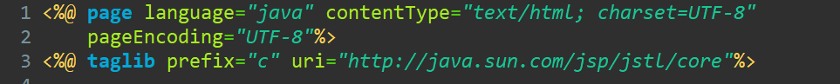
Declaring Variable and printing using c:set and c:out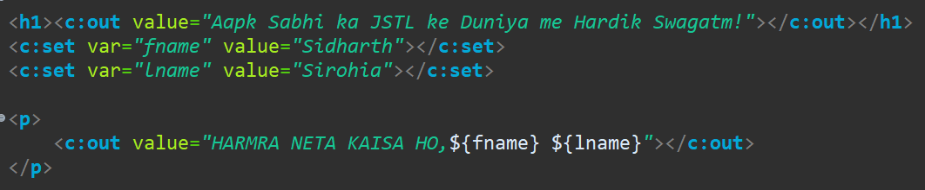
C:if
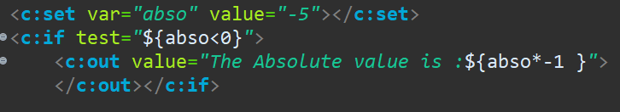

C:choose (for nested if else)
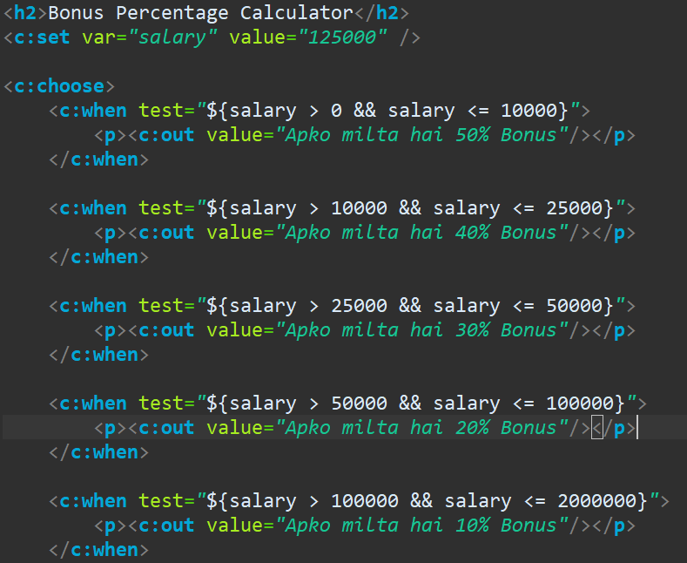

MVC Design Pattern
Model View Controller
Model
Mapping Handle
(Servlet)
Client
Controller
CLIENT Request
Response

View (JSP)

MVC Design pattern is a software architectural pattern that separates an application into three main components
- Model Layer
- View Layer
- Controller Layer
Model Layer
- This layer represents the core data and business logic of our application.
- It typically consists of java classes that encapsulates data and functionality. These classes are of POJO (Plain old java object)
- Data persistence – The model interacts with databases to store and retrieve information. This can be done using JDBC or ORM tools
View Layer
- This layer focuses on how application is presented to the client
- In JSPN servlet development JSP pages are the main part of view layer
Controller Layer
- This layer serves as the central herb for handling user request and interactions.
- Servlets are commonly used as controller in MVC design pattern.
- Servlets goal in MVC flow are receiving request, processing request, selecting view and forwarding request
Benefits of MVC
- Improved maintain ability
- Increased reusability

Framework
It is pre build foundation that provides basic structure for an application it saves time, reduces errors pronounce reusability, etc.
It is ready made architecture and it needs configurations.

ORIM (Object relational impedance mismatch)
The ORIM are the issues that arise when we try to fit data structures from OOPS into a RDBMS
Major Issues
- Different platforms
- Mapping Issue

Object Relational Mapping
ORM acts as bridge between OOPS and RDB, simplifying the process of working with both the platforms seeing Lessley. ORM does the following things:
- It maps object with the database table
- Provides abstraction
- Automates data persistence
- Reduce boiler plate code

Hibernate
Hibernate framework is a popular open-source framework used in a java application for interacting with RDB, simplifying data persistence.
It acts as object relational mapper which bridges the gap between OOPS and RDBMS
Key features of hibernate are:
- Object oriented persistence
- JPA (Java Persistence API) provider
- Idiomatic persistence: It enables development using natural object-oriented concepts like inheritance, polymorphism and collections.
- Live performance
- Scalable
- Reliable
- Extensible: easy to customize
Hibernate Configuration
In Hibernate Configuration, session factory and session are fundamental components that work together to manage persistence between java application and RDB. This stage establishes the foundation of our hibernate integration with our RDB. It involves defining various ways to configure settings that govern how hibernate operates.
Session Factory
Once the configuration is complete, we build a session factory object using bulidSessionFactory() of the Configuration class. It produces light weight session object and acts session object as a central point for managing DB connection
Session
Session object represents single unit of work with the DB. It provides method for interacting with DB

